2.7 Improper Integrals

Motivation:
Suppose we want to find the area of the region, R, given by . A picture of this region is shown below (in yellow):

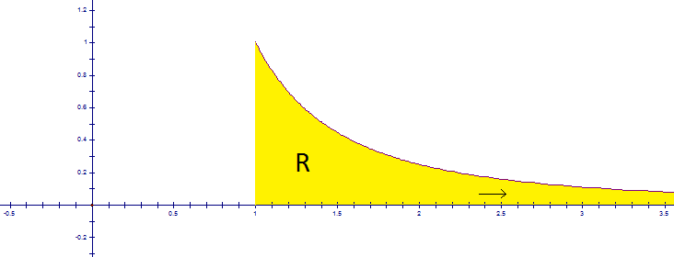

The key question here is: does the area under the above curve approach a finite number?

To answer this question we can use integration. Specifically we calculate:

So, we say that the area of the region R is one.

Definition (Improper Integral of Type 1):

- If exists for every number , then provided this limit exists (as a finite number).
- If exists for every number , then provided this limit exists (as a finite number).

Definition: The improper integrals and are called convergent if the corresponding limit exists (as a finite number), and are called divergent if the limit does not exist.

Definition: If both and are convergent, then we define where a can be taken to be any real number.

Note: To shed some light as to why a can be taken to be any real number in this definition you can consider the following question:
If is convergent and $a$ and $b$ are real numbers, show that:

Example 1 (you try): Determine whether is convergent or divergent. If it is convergent evaluate the integral.

We see that . Since the limit does not exist as a finite number we say that the improper integral is divergent.

Example 2: Evaluate

We use tabular integration (or integration by parts) and find:

Now, we use l’Hospital’s Rule and we see: .
Example 3: Evaluate .

Using the above definition, we take (since it will be convenient). By definition we know that provided that the two integrals on the right hand side of this equation are convergent. Now, we calculate:

The next definition gives us a way of dealing with vertical asymptotes as they arise in functions that we integrate.

Definition (Improper integral of Type 2):
- If is continuous on and discontinuous at b, then provided this limit exists (as a finite number).
- If is continuous on and discontinuous at a, then provided this limit exists (as a finite number).

Note: The notions of convergent and divergent are defined similar to the way in which we defined them for Improper Integrals of Type 1.

Definition: If has a discontinuity at c, where (and is continuous on and ) and both and are convergent, then we define .

Example 4: Evaluate if possible.

We first note that is continuous on and discontinuous at . So, by the above definition
we have:
Thus, the given improper integral is divergent.

Example 5 (you try): Consider the following problem: Evaluate if possible. Explain what is wrong with the following solution:

This solution fails to take into account the fact that has a discontinuity at 1. Therefore, it is an improper integral and must be computed in terms of limits.

Note: It can be shown that the above integral is actually divergent.

Question:
Does converge to a finite number?

This question is particularly difficult because we know that we cannot find an antiderivative for in terms of elementary functions. The next theorem will give us a tool which can be helpful in answering questions like these.

Theorem (Comparison Theorem):
Suppose that and are continuous functions with for .

- If is convergent, then is convergent.
- If is divergent, then is divergent.

Note: This theorem is called the comparison theorem by the book. Since the book omits the proof of this theorem, I too will omit it. However, if you would like to discuss the proof of this theorem feel free to stop by office hours.

Example 6: Prove that is convergent.

We know that . Now, by the properties of definite integrals we have: .

We note that is just an ordinary definite integral, and hence is finite. Now, we note that . This implies that on the interval .

This is a very nice relation to have since is easy to evaluate. Specifically, we calculate: . By part 1 of the comparison theorem, we know that this means is convergent. This then implies that is convergent.

Note: Usually the most challenging part of a proof that uses the comparison theorem is finding a “nice” integral to which to compare the integral of interest.

Example 7: Gabriel’s horn is the solid obtained by rotating the region about the x-axis, find whether or not the surface area is finite.

We are interested in surface area of the solid obtained by revolving the curve given by where about the x-axis. By definition the desired surface area is:
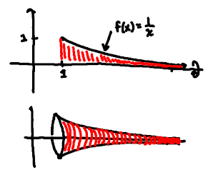
We note that for we have . Also, we have that . So, by the comparison theorem: is divergent and we know that the surface area of Gabriel’s horn is infinite.

Note: Interestingly we can also prove that the volume of Gabriel’s horn is finite!

Volume Calculation:

A finite volume!!!

So Gabriel’s Horn has:
- Infinite surface area &
- Finite volume

This is like a paint can that cannot hold enough paint to paint its own exterior!

